Week 4

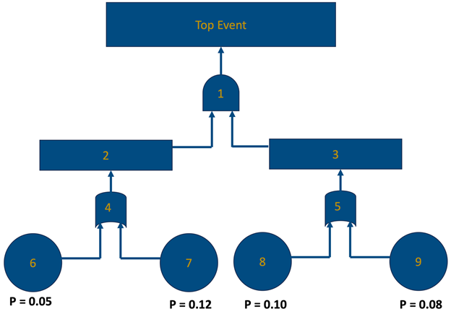***Questions 1-4 will be referring to the following fault tree:***

1. **The symbol labeled with "2" represents which of the following?**

**Intermediate event**

**AND gate**

**OR gate**

**Basic event**

1. **The symbol labeled with "7" represents which of the following?**

**OR gate**

**Basic event**

**AND gate**

**Intermediate event**

1. **The symbol labeled with "5" represents which of the following?**

**AND gate**

**Basic event**

**Intermediate event**

**OR gate**

1. **Based on the probabilities of failure defined in the fault tree, what is the probability of failure associated with the top event?**

**0.308**

**0.336**

**0.028**

**0.014**

1. **Which of the following is the best description of a bowtie diagram?**

**A bowtie diagram describes the progression to an initiating event to final potential results.**

**A bowtie diagram is a method for identifying which hazards can lead to an incident, starting from a top event representing the incident and working backwards to basic events.**

**A bowtie diagram connects the top event of a fault tree to the initiating event of an event tree, and identifies safeguards that can prevent and mitigate hazards.**

**A bowtie diagram is a semi-quantitative and simplified form of quantitative risk analysis using order of magnitude categories for determining event frequency, consequence severity, and likelihood of failure of safeguards.**

1. **Which of the following are criterion for an independent layer of protection? (Select all that apply).**

**Auditability**

**Management of change**

**Reliability**

**Controllability**

1. **The target mitigated event frequency of an event is 10-6/yr. If the adjusted initiating event frequency is 10-3/yr, and safeguards are in place that have a combined probability of failure on demand of 10-2/yr, which of the following additional safeguards could be used in order to bring the risk to a tolerable level, assuming that each of these safeguard options are applicable in this situation? (Select all that apply).**

**Human action within 10-minute response time, PFD = 10-1/yr**

**Blast wall, PFD = 10-3/yr**

**No additional safeguards are necessary – risk is tolerable**

**Dike, PFD = 10-2/yr**

1. **Which of the following are inherently safer design principles? (Select all that apply).**

**Access security**

**Substitute**

**Simplify**

**Minimize**

1. **Reducing inventories of a hazardous process intermediate is an example of applying which inherently safer design principle?**

**Simplify**

**Minimize**

**Moderate**

**Substitute**

1. **Designing unit operations to run at lower temperatures and/or lower pressure is an example of applying which inherently safer design principle?**

**Substitute**

**Simplify**

**Moderate**

**Minimize**